What is the decision making statement and why use it
There come situations in real life when we need to make some decisions and based on these decisions, we decide what we should do next. Similar situations arise in programming also where we need to make some decisions and based on these decisions we will execute the next block of code. For example, in C if x occurs then execute y else execute z. There can also be multiple conditions like in C if x occurs then execute p, else if condition y occurs execute q, else execute r. This condition of C else-if is one of the many ways of importing multiple conditions.
Explain the Types of Decision Making Statement?
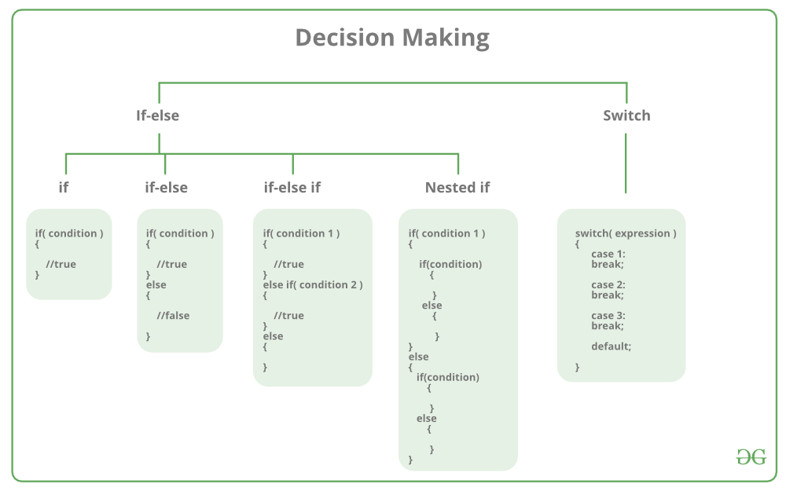
Explain the switch statement?
Switch case statement evaluates a given expression and based on the evaluated value (matching a certain condition), it executes the statements associated with it. Basically, it is used to perform different actions based on different conditions (cases).
- Switch case statements follow a selection-control mechanism and allow a value to change control of execution.
- They are a substitute for long if statements that compare a variable to several integral values.
- The switch statement is a multiday branch statement. It provides an easy way to dispatch execution to different parts of code based on the value of the expression.

Syntax:
switch (n)
{ case 1: // code to be executed if n = 1;
break;
case 2: // code to be executed if n = 2;
break;
default: // code to be executed if n doesn't match any cases
}
Some important keywords:
1) Break: This keyword is used to stop the execution inside a switch block. It helps to terminate the switch block and break out of it.
2) Default: This keyword is used to specify the set of statements to execute if there is no case match.
Important Points About Switch Case Statements:
1) The expression provided in the switch should result in a constant value otherwise it would not be valid. Some valid expressions for switch case will be,
// Constant expressions allowed
switch(1+2+23)
switch(1*2+3%4)

// Variable expression are allowed provided
// they are assigned with fixed values
switch(a*b+c*d)
switch(a+b+c)
2) Duplicate case values are not allowed.
3) The default statement is optional. Even if the switch case statement does not have a default statement, it would run without any problem.
4) The break statement is used inside the switch to terminate a statement sequence. When a break statement is reached, the switch terminates, and the flow of control jumps to the next line following the switch statement.
5) The break statement is optional. If omitted, execution will continue on into the next case. The flow of control will fall through to subsequent cases until a break is reached.
6) Nesting of switch statements is allowed, which means you can have switch statements inside another switch. However nested switch statements should be avoided as it makes the program more complex and less readable.
7) Switch statements are limited to integer values only in the check condition.

Find the output of given code
#include <stdio.h>
int main()
{ float x = 1.1;
switch (x)
{ case 1.1: printf("Choice is 1");
break;
default: printf("Choice other than 1, 2 and 3");
break;
}
return 0;
}
What will be the output of given code?
// There is no break in all cases
#include <stdio.h>
int main()
{ int x = 2;
switch (x)
{ case 1: printf("Choice is 1\n");
case 2: printf("Choice is 2\n");
case 3: printf("Choice is 3\n");
default: printf("Choice other than 1, 2 and 3\n");
}
return 0;
}
What will be the output of given code?
#include <stdio.h>
int main()
{ int x = 2;
switch (x)
{
case 1: printf("Choice is 1\n");
case 2: printf("Choice is 2\n");
case 3: printf("Choice is 3\n");
case 4: printf("Choice is 4\n");
break;
default: printf("Choice other than 1, 2, 3 and 4\n");
break;
}
printf("After Switch");
return 0;
}
What will be the output of given code?
// A program with variable expressions in labels
#include <stdio.h>
int main()
{
int x = 2;
int arr[] = {1, 2, 3};
switch (x)
{
case arr[0]: printf("Choice 1\n");
case arr[1]: printf("Choice 2\n");
case arr[2]: printf("Choice 3\n");
}
return 0;
}
What will be the output of given code
// Statements before all cases are never executed
#include <stdio.h>
int main()
{ int x = 1;
switch (x)
{
x = x + 1; // This statement is not executed
case 1: printf("Choice is 1");
break;
case 2: printf("Choice is 2");
break;
default: printf("Choice other than 1 and 2");
break;
}
return 0;
}
What will be the output of given code?
// Program where two case labels have same value
#include <stdio.h>
int main()
{
int x = 1;
switch (x)
{ case 2: printf("Choice is 1");
break;
case 1+1: printf("Choice is 2");
break;
}
return 0;
}
What will be the output of given code?
#include <stdio.h>
void main()
{ int x = 5;
if (x < 1)
printf("hello");
if (x == 5)
printf("hi");
else
printf("no");
}
What will be the output of given code
#include <stdio.h>
int x;
void main()
{ if (x)
printf("hi");
else
printf("how are u");
}
What will be the output of given code
#include <stdio.h>
void main()
{ int x = 5;
if (x < 1);
printf("Hello");
}
what will be the output of given code ?
#include <stdio.h>
void main(){
int ch;
printf("enter a value between 1 to 2:");
scanf("%d", &ch);
switch (ch, ch + 1)
{
case 1:
printf("1\n");
break;
case 2:
printf("2");
break;
}
}
What will be the output of given code
#include<stdio.h>
#include<conio.h>
void main()
{ int x = 10,y = 5, p,q;
p = x > 9;
q = x > 3 && y!=3;
printf ("p = %d q = %d", p, q);
getch();
}
What will be the output of given code
#include<stdio.h>
#include<conio.h>
void main()
{
int a = 30, b = 40, x;
x = (a!=10)&&(b = 50);
printf ("x = %d",x);
getch();
}
What will be the output of given code?
#include<stdio.h>
#include<conio.h>
void main()
{
int a = 100, b = 200, c;
c = (a==100||b>200);
printf ("c = %d",c);

getch();
}
What will be the output of given code?
#include<stdio.h>
#include<conio.h>
void main ()
{ int x = 11,y = 6,z;
z = x == 51| y! = 4 ;
printf ("z = %d",z );
getch ();
}
What will be the output of given code
#include<stdio.h>
#include<conio.h>
void main()
{ int a = 300, b=10, c = 20;
if(!(a>=400))
b = 300;
c = 200;
printf ("b = %dc = %d", b,c)
getch();
}
What will be the output of given code?
#include<stdio.h>
#include<conio.h>
void main ()
{ int a = 500, b = 100,c;
if (!a>=400)
b = 300;
c = 200;
printf ("b = %dc = %d", b,c);
getch ();
}
What will be the output of given code?
#include<stdio.h>
#include<conio.h>
void main()
{ int x = 10,y = 100%90;
if(x!=y);
printf ("x = %d y = %d", x, y);
getch();
}
What will be the output of given code ?
#include<stdio.h>
#include<conio.h>
void main()
{ int x = 10, y = -20;
x = !x;
y=!y;
printf ("x = %dy = %d\n",x,y);
getch();
}
What will be the output of given code?
#include<stdio.h>
#include<conio.h>
void main()
{ int x = 0, y = 1;
y = !x;
x = !y;
printf ("x = %d y = %d\n", x,y);
getch();
}
What will be the output of given code?
#include<stdio.h>
#include<conio.h>
void main() {
if (13.14)
printf ("I have robbed and killed...");
else
printf ("Until my evil purse was filled")
getch();
}
What will be the output of given code?
#include<stdio.h>
#include<conio.h>
void main()
{ int x = 3, y = 4, z = 4;
printf("ans = %d", (z>=y>=x?100:200));
getch();
}
What will be the output of given code?
#include<stdio.h>
#include<conio.h>
void main()
{ float a =12.25, b=13.65;
if (a = b)
printf ("a and b are equal");
else
printf ("a and b are not equal");
getch();
}
What will be the output of given code?
#include<stdio.h>
#include<conio.h>
void main()
{ if('Z'<'z')
printf ("Pilots are on strike...");
else
printf ("for absolutely outlandish demands")
getch ();
}
What will be the output of given code?
#include<stdio.h>
#include<conio.h>
void main()
{ int x = 10;
if x >= 2
printf ("%d\n",x);
getch();
}
What will be the output given code?
#include<stdio.h>
#include<conio.h>
void main()
{ int i = 10, j = 40;
if((j-i)%10)
printf ("man sees your actions..");
else
printf ("god sees your motives..");
getch();
}
What will be the output of given code?
#include<stdio.h>
#include<conio.h>
void main()
{ int i = -4, j, num = 10;
j = i%-3;
j = (j ? 0: num * num);
printf ("j = %d",j);
getch();
}

What will be the output of given code?
#include<stdio.h>
#include<conio.h>
void main()
{ float a = 0.7;
if (a< 0.7)
printf ("Stoned");
else
printf ("Avenged");
getch();
}
What will be the output of given code?
#include<stdio.h>
#include<conio.h>
void main()
{ int i = 400 * 400/400;
if (i == 400)
printf ("Filibusters");
else
printf ("Sea gherkins");
getch();
}
What will be the output of given code?
#include<stdio.h>
#include<conio.h>
void main()
{ int k = 12,n = 30;
k = (k>5 && n = 4 ? 100:200);
printf ("k = %d*,k);
getch();
}
What will be the output of given code?
#include<stdio.h>
#include<conio.h>
void main()
{ int c = 0, d = 5, e = 10, a;
a = c> 1 ? d > 11| e > 1 ? 100:200:300;
printf ("a = %d", a)
getch();
}
What will be the output of given code?
#include<stdio.h>
#include<conio.h>
void main() {
int a = 10, b = 10;
printf ("ans = %d", a>b?a*a:b/b);
getch();
}
What will be the output of given code?
#include<stdio.h>
#include<conio.h>
void main()
{ float a= 0.5, b= 0.9;
if (a && b > 0.9)
printf ("IDLENESS IS A VIRTUE..");
else
printf ("..SO IS STUPIDITY!");
getch ();
}
What will be the output given code?
#include<stdio.h>
#include<conio.h>
void main(){
int x = 100;
if (!!X)
printf("x = %d", !x);
else
printf("x = %d",x);
getch();
}

